UPPER CAPE SKI CLUB
STEAMBOAT SPRINGS, CO. FEB. 21 -28, 2015 $1575
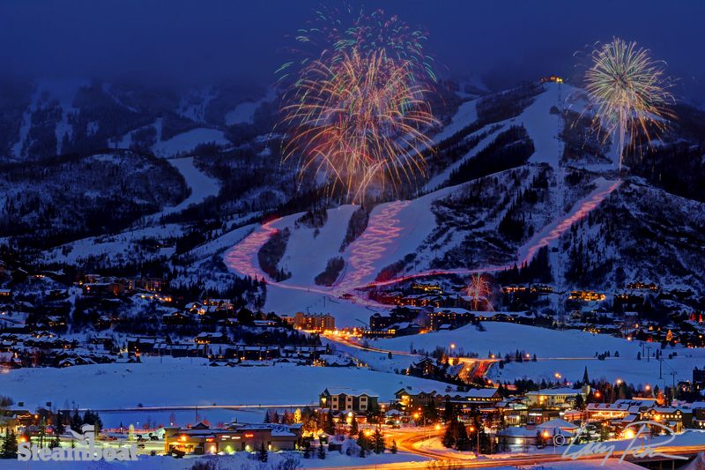
AIR & GROUND TRANSPORTATION:
FEB 21: UA339 BOS/DEN 745A 1033A, UA3871 DEN/HDN 1115A 1207P
FEB 28: UA3871 HDN/DEN 1235P 134P, DEN/BOS 522P 1112P
ROUND TRIP GROUND TRANSFERS TO/FROM AIRPORT ARE INCLUDED
LIFT TICKETS
A 5 of 7 day lift ticket is included with an option for a 6th day
Steamboat skiing is legendary, as those of you who are re-visiting can attest.
LODGINGS
LA CASA CONDOS. Mountain living at its best. With high-soaring ceilings and multi-levels of uncrowded space, it is an ideal lodging choice. The main floor kitchen is large, efficient, and imaginatively furnished with all necessary cookware. It has a huge pantry, adjoining laundry room with a full size washer and dryer. Dining and living area a few steps away. The main floor has a wet bar and an extra guest bath. The upper level has exceptionally private and quiet bedrooms, each with its own private bath. Amenities: 100 yards to the slopes. Shuttle service, daily housekeeping, outdoor hot tubs, fireplace, and TV are among the amenities. Go to: www.steamboatresorts.com/accommodations/la-casa for more details.

Call or E-mail Bud Shaw (budco1@comcast.net, 508 477 3717)

